Spring REST using Spring Boot 3
Hands-on: REST - Get Country Based on Country Code

Project Structure

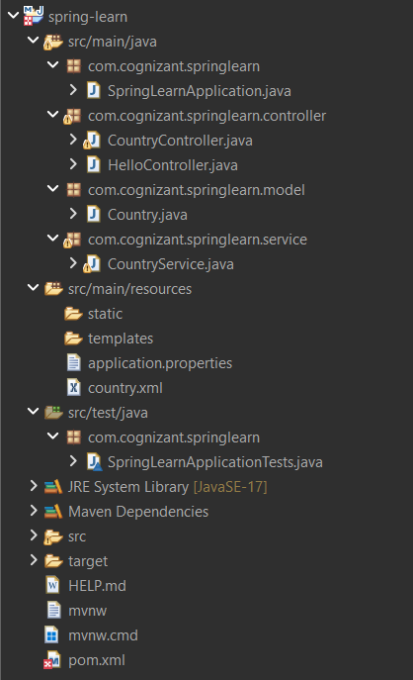

country.xml
<?xml version="1.0" encoding="UTF-8"?>
<beans xmlns="http://www.springframework.org/schema/beans"
xmlns:xsi="http://www.w3.org/2001/XMLSchema-instance"
xsi:schemaLocation="
http://www.springframework.org/schema/beans
https://www.springframework.org/schema/beans/spring-beans.xsd">
<bean id="india" class="com.cognizant.springlearn.model.Country">
<property name="code" value="IN"/>
<property name="name" value="India"/>
</bean>
<bean id="usa" class="com.cognizant.springlearn.model.Country">
<property name="code" value="US"/>
<property name="name" value="United States"/>
</bean>
<bean id="japan" class="com.cognizant.springlearn.model.Country">
<property name="code" value="JP"/>
<property name="name" value="Japan"/>
</bean>
<bean id="germany" class="com.cognizant.springlearn.model.Country">
<property name="code" value="DE"/>
<property name="name" value="Germany"/>
</bean>
</beans>

CountryService.java
package com.cognizant.springlearn.service;
import java.util.Arrays;
import java.util.List;
import org.springframework.context.ApplicationContext;
import org.springframework.context.support.ClassPathXmlApplicationContext;
import org.springframework.stereotype.Service;
import com.cognizant.springlearn.model.Country;
@Service
public class CountryService {
public Country getCountry(String code) {
ApplicationContext context =
new ClassPathXmlApplicationContext("country.xml");
List<Country> countries = Arrays.asList(
(Country) context.getBean("india"),
(Country) context.getBean("usa"),
(Country) context.getBean("japan"),
(Country) context.getBean("germany"));
for (Country country : countries) {
if (country.getCode().equalsIgnoreCase(code)) {
return country;
}
}
return null;
}
}

CountryController.java
package com.cognizant.springlearn.controller;
import java.util.Arrays;
import java.util.List;
import org.springframework.beans.factory.annotation.Autowired;
import org.springframework.context.ApplicationContext;
import org.springframework.context.support.ClassPathXmlApplicationContext;
import org.springframework.web.bind.annotation.GetMapping;
import org.springframework.web.bind.annotation.PathVariable;
import org.springframework.web.bind.annotation.RestController;
import com.cognizant.springlearn.model.Country;
import com.cognizant.springlearn.service.CountryService;
@RestController
public class CountryController {
@Autowired
private CountryService countryService;
@GetMapping("/country")
public Country getCountryIndia() {
ApplicationContext context =
new ClassPathXmlApplicationContext("country.xml");
return (Country) context.getBean("india");
}
@GetMapping("/countries")
public List<Country> getAllCountries() {
ApplicationContext context =
new ClassPathXmlApplicationContext("country.xml");
return Arrays.asList(
(Country) context.getBean("india"),
(Country) context.getBean("usa"),
(Country) context.getBean("japan"),
(Country) context.getBean("germany"));
}
@GetMapping("/countries/{code}")
public Country getCountry(@PathVariable String code) {
return countryService.getCountry(code);
}
}

Test URLs
http://localhost:9090/country
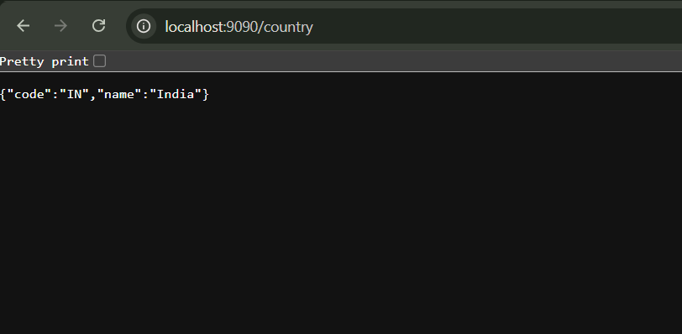
http://localhost:9090/countries
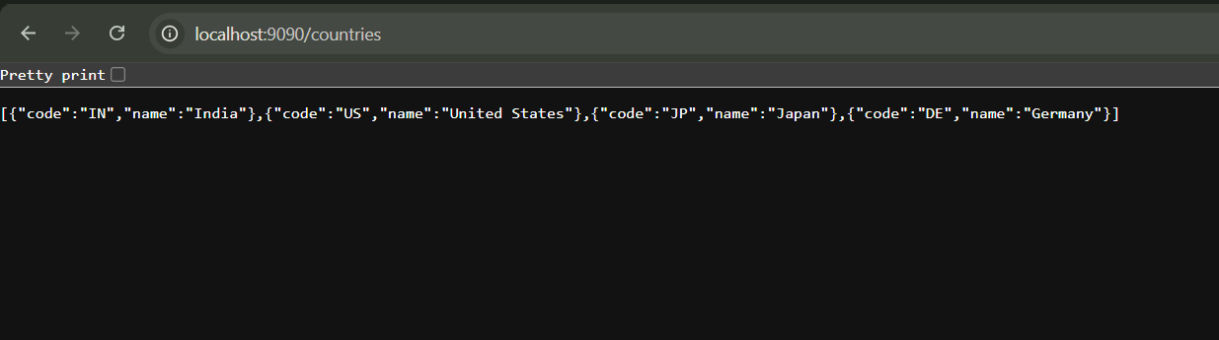

http://localhost:9090/countries/IN
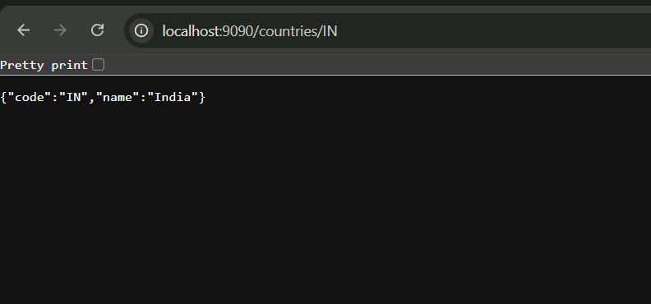
http://localhost:9090/countries/us
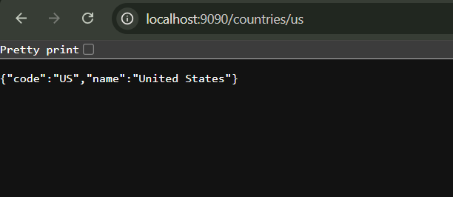
http://localhost:9090/countries/JP
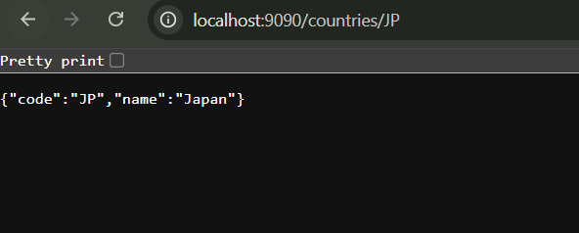

Console Output
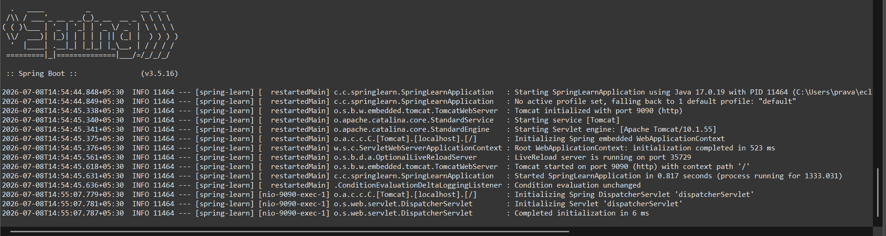

Conclusion
The REST service was successfully implemented using Spring Boot. The application retrieves all countries and individual countries by code. Country lookup is case-insensitive and all APIs were tested successfully.

